Semester Project

Linear Control Systems

(Buck Converter)



|  |  |  |
| --- | --- | --- |
| Ali Aqdas | 285050 | **BEE-11B** |
| Abdul Hanan Gul Khan | 289864 |
| Abdur Rafae Haqqani | 307327 |
| Ali Ashraf | 292926 |

National University of Science and Technology

School of Electrical Engineering and Computer Sciences

# Introduction

The objective of this project is to design a buck converter of the below given specifications. A buck converter is a DC-DC Converter which can step-down DC Voltage at high efficiency with minimal power loss.

The report summarizes design procedure and results of our simulation.

# Desired Specifications

|  |  |  |  |  |  |
| --- | --- | --- | --- | --- | --- |
| **Input Voltage** | **Voltage Ripple** | **Current Rating** | **Overshoot** | **Transistor $R_{on}$** | **Inductor Resistance** |
| $$28±4 V$$ | $$±2\%$$ | $$1-10 A$$ | $$≤20\%$$ | $$0.01Ω$$ | $$0.1Ω$$ |

# Design Procedure

## Deriving Transfer Function for Buck Converter

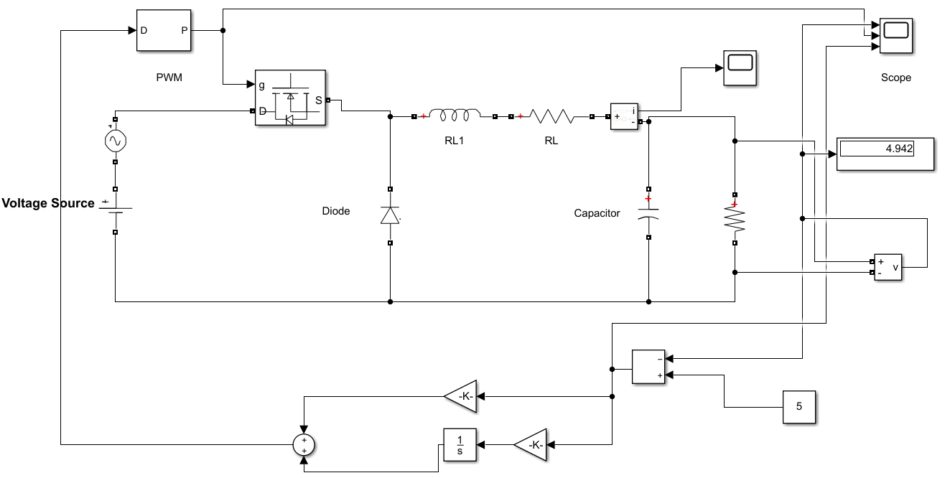

Figure 1 Simulation Diagram

We know that

$$Duty Cycle=d=\frac{t_{on}}{T}$$

where T is the time period of Switching Signal. Also,

$$L\frac{di_{L}}{dt}=v_{L}$$

Since there are two states of the circuit due to switching mechanism, therefore we use weighted average

$$L\frac{di_{L}}{dt}=\left(v_{i}-v_{1}\right)d+(-v_{1})(1-d)$$

Where $v_{1}=i_{L}R_{ind}+v_{c}$

$$L\frac{di_{L}}{dt}=\left(v_{i}-i_{L}R_{ind}-v_{c}\right)d+({-i}_{L}R_{ind}-v_{c})(1-d)$$

$$L\frac{di_{L}}{dt}=v_{i}d-i_{L}R_{ind}d-v_{c}d-i_{L}R_{ind}+i_{L}R_{ind}d-v_{c}+v_{c}d=v_{i}d-i_{L}R_{ind}-v_{c}$$

$$\frac{di_{L}}{dt}=\frac{v_{i}d}{L}-\frac{i_{L}R_{ind}}{L}-\frac{v_{c}}{L}→\left(1\right)$$

Similarly,

$$C\frac{dv_{c}}{dt}=i_{c}$$

Given that capacitor voltage is unaffected by switching mechanism, we do not need to incorporate the changes we did in inductor voltage

$$C\frac{dv_{c}}{dt}=i_{L}-i_{R}=i_{L}-\frac{v_{c}}{R}$$

$$C\frac{dv_{c}}{dt}=i_{L}-\frac{v_{c}}{R}→(2)$$

Taking Laplace Transform of $\left(2\right)$ we get

$$sCV_{c}=I_{L}-\frac{V_{C}(s)}{R} ⟹ I_{L}=V_{C}\left(sC+\frac{1}{R}\right)→(3)$$

Similarly for $(1)$ we get

$$sI_{L}=\frac{V_{i}}{L}D-\frac{I_{L}R_{ind}}{L}-\frac{V_{C}}{L}$$

Substituting $(3)$

$$sV_{c}\left(sC+\frac{1}{R}\right)=\frac{V_{i}}{L}D-\frac{R_{ind}V_{C}}{L}\left(sC+\frac{1}{R}\right)-\frac{V_{C}}{L}$$

$$V_{c}\left(s^{2}C+s\frac{1}{R}+\frac{1}{L}+s\frac{R_{ind}C}{L}+\frac{R_{ind}}{RL} \right)=\frac{V_{I}}{L}D$$

$$\frac{V_{C}(s)}{D\left(s\right)}=\frac{V_{I}}{L\left(s^{2}C+s\frac{1}{R}+\frac{1}{L}+s\frac{R_{ind}C}{L}+\frac{R_{ind}}{RL} \right)}$$

$$\frac{V_{C}(s)}{D\left(s\right)}=\frac{\frac{V_{i}}{LC}}{\left(s^{2}+s(\frac{1}{RC}+\frac{R_{ind}}{L})+\frac{1}{LC}+\frac{R_{ind}}{RLC}\right)}$$

Since maximum overshoot must be $≤20\%$, we use a overshoot of approximately $15\%$ to be on the safe side. Inductor and Capacitor were chosen based on the availability of concerned values. After choosing the inductor and capacitor, the switching frequency was determined using Bode Plot.

We chose $L=3mH$ and $C=22μF$

## Determining Switching Frequency

The requirement for our output is to have ripples less than 5% of our output voltage i.e. 5 volt which is equal to be 0.1 volt. So we used bode plot to find the frequency at which our output would satisfy the condition.

Now for finding the frequency, our system can have loads from 0.5 ohm to 5 ohm. Thus we plot bode plot for all the systems. We observe that our condition for ripples is satisfied at **-20dB**. We can see that at the same frequency of **10 kHz**, the gain for 5 $Ω$, system is highest i.e. -20dB. So we select the frequency according to 5 $Ω$. Therefore, the gain for all the other higher loads will be according to our requirement.

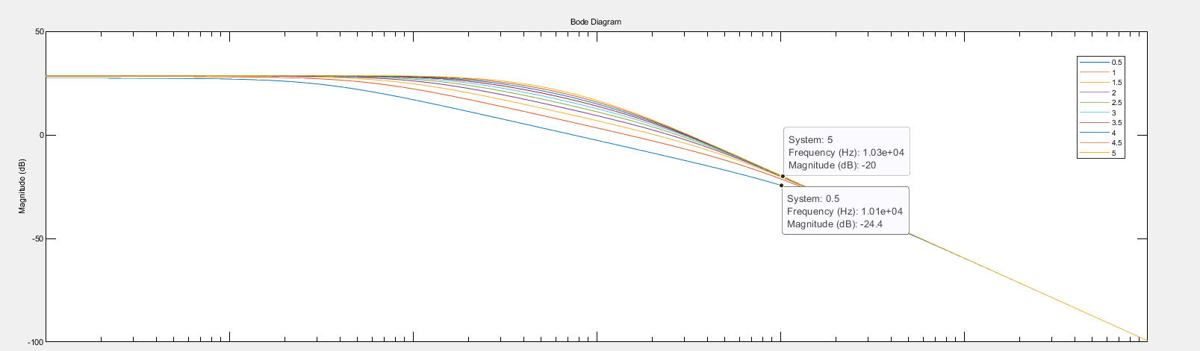

## Root Locus for finding Gain

Now for finding the gain of our PI controller, we use the root locus. A plot containing root locus for system having different plots is shown below:

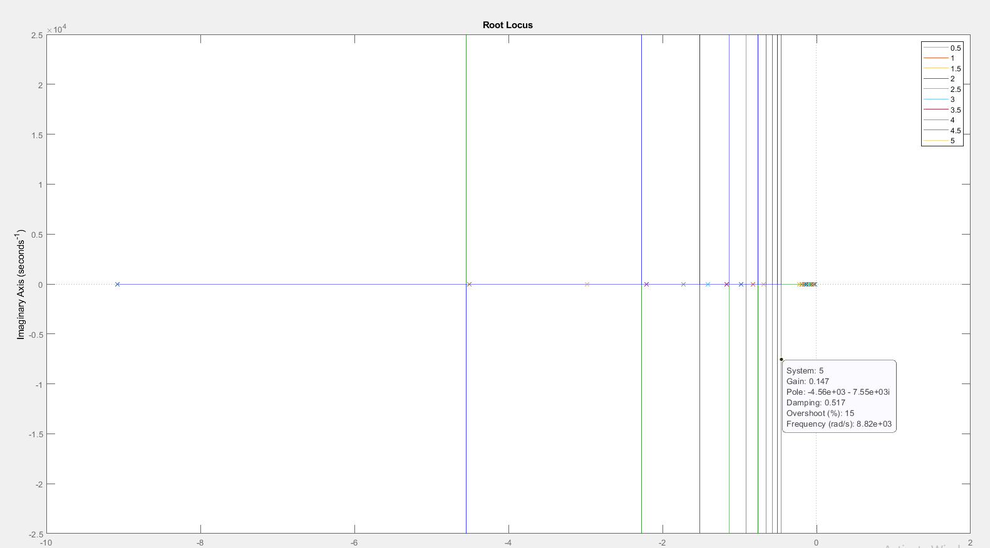

As we know that the overshoot is maximum for the mimimum load, therefore we use our 5 $Ω$ system to find the required gain.

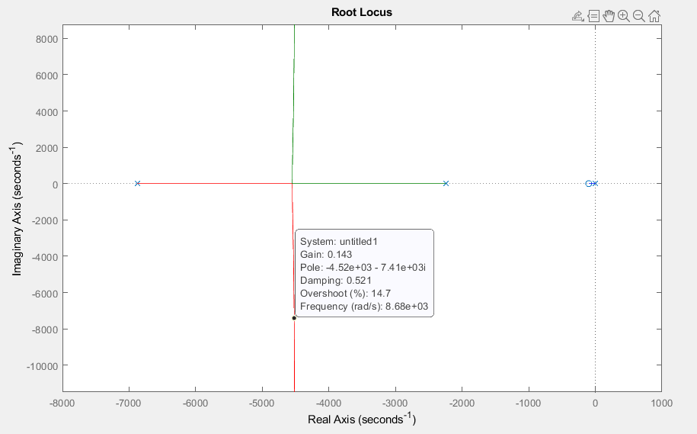

Our requirement for the overshoot is that it should be less than 20%. Thus, we find a point with overshoot **14.7%** and a gain of **0.143** which gives us the required results.

# Results

The below figures summarize the response of our buck converter at maximum and minimum load.

### RL = 5Ω

**Overall Response**

**Zoom-in on Overshoot**

**Zoom-in on Steady State**

### RL = 0.5Ω

**Overall Response**

**Zoom-in on Steady State**

### Explanation

In the design of a controller to meet the overshoot specifications (%OS < 20), our two extremes were load resistances of 0.5 Ω and 5 Ω. By plotting the root loci, we saw that the root locus for our system with the 5 Ω resistor met our overshoot specification at a lower gain than our system with the 0.5 Ω resistor. Thus, by setting the controller gain for the worst-case scenario of 5 Ω load, the specifications are exceeded for the 0.5 Ω load, i.e., we achieve smaller overshoot for the 0.5 Ω load. This can be seen in our waveforms, where there is virtually no overshoot in the case of 0.5 Ω resistor, and an overshoot of about 0.4 V for the 5 Ω load, i.e., an overshoot of 8%, which is still well within our specifications.

Furthermore, in both cases, the ripple in the steady state is also well within our ±2% (±0.1 V) requirement.

# Component Selection

1. $28 V$ Lithium Banshee Battery ($89 or 18000PKR) - Optional

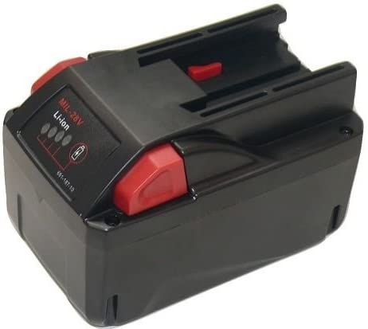

1. $3mH$ $10A$ Toroidal Inductor ($0.8 or 160PKR)

1. ,, Tantalum Capacitor ($0.59 or 119PKR)

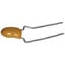

1. IRF9540 Power MOSFET, Maximum Operating Frequency > 1MHz ($0.3 or PKR60)
   1. We have chosen this MOSFET because it can operate on frequencies higher than 1MHz while our desired switching frequency is 10kHz. It can also operate at our desired input voltage of $28 V.$

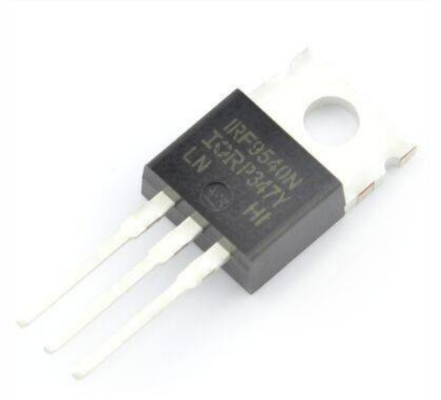

1. Diode 1N4007 ($0.0050 or 1PKR)

1. Arduino for Compensator Design and PWM Control (1750 PKR)

1. 2 Wire 0.28 Inch mini-DC voltmeter ($0.84 or 170PKR) - Optional

Excluding the optional items, our total cost is $2260 PKR$. Which is considerably high for consumer applications. However, for mass-production the cost will be minimized extremely, lowering the cost of discrete components and controller.

# Conclusion

Designing a buck converter, we learned different parts of designing an electronics circuit. Deriving the transfer function was the most critical part of whole design. We then had to design a controller to compensate the response.